Analysis of Hall and Micro-grid data for paper 5

1. Period of study – The data is analysed for both interventions over a 6 months period since commissioning. The period of study for each is as follows
   1. Hall: 19th July 2019 to 31st Dec 2019
   2. Micro-grid: 2nd July 2019 to 31st Dec 2019
2. Infrastructure – The systems consist of the following users/devices
   1. Hall
      1. CPE - 7 CPE wherein each CPE consists of 3 LEDs (LED[1,2,3]).
      2. Sockets – 4 sockets
   2. Micro-grid
      1. Nursery 1 – 6 CPE wherein each CPE consists of 3 LEDs (LED[1,2,3]) and 4 sockets
      2. Nursery 2 – 6 CPE wherein each CPE consists of 3 LEDs (LED[1,2,3]) and 4 sockets
      3. Playground - 5 CPE wherein each CPE consists of 3 LEDs (LED[1,2,3]) and 2 sockets
      4. Streetlights – 3 CPE wherein each CPE consists of 3 LEDs (LED[1,2,3])
3. Input data – Following data is used for each device
   1. CPE data – For each CPE, instantaneous power values are used (LED[1,2,3]_P)
   2. Socket data – For each socket, instantaneous power values are used (vRELAY_LVL)
   3. System data – For each intervention, AC consumption, PV power, Charged energy, Discharged energy, State of charge values are used
   4. Weather data – For each intervention, Pot PV power values are used
4. Data pre-processing – Raw data for each of the above variables is obtained and summarised to obtain hourly values. Hourly mean values are calculated for instantaneous power of CPE and sockets, AC consumption, PV power and Pot PV power values. The values are calculated for 24 hours per day (0-23 hours) such that the value at ith hour is the mean of all values obtained between i and (i+1) hour. The charged energy discharged energy are cumulative values and the value for each hour is calculated by calculating the difference in last recorded value per hour. The hourly state of charge value is the last recorded value in a given hour.
5. Assessing data quality – Prior to analysis, the hourly data for each device is assessed to evaluate the yield of data collection. Below plots show the missing data per variable per day and the overall yield of data collection per device.

Fig. 1: Hours of data collection for CPE and sockets at the Hall per day from 19th July 2019 to 31st Dec 2019. The plots show that data is missing quite a bit across different CPE over time, however, no CPE is fully unavailable on any day (data for at least 1 hour is available). For socket S3, the instantaneous power values are not recorded for some consecutive days in Nov 2019 (0 hours of data collection across days).

Fig. 2: Hours of data collection for CPE and sockets at the Micro-grid per day from 02nd July 2019 to 31st Dec 2019. A large number of missing values are noted here for both CPE and sockets reflecting poor yield of data.

Fig. 3: Yield for CPE and sockets at the Hall. Yield is calculated as the % of hours per day for which data is available (i.e. number of hours of available data * 100/24). As is reflected from the above plots, the yield is quite high for both CPE and sockets, with the exception of a few days in Nov 2019 when the yield for sockets is ~25%. For all other cases, the yield is >75%.

Fig. 4: Yield for CPE and sockets at the Micro-grid. Yield is calculated as the % of hours per day for which data is available (i.e. number of hours of available data * 100/24). As is reflected from the above plots, the yield is quite high for both CPE and sockets for days when the data files are available (in excess of 75%). However, the data files for some CPE and sockets are altogether missing for periods in Sep and Nov when the system was down.

1. Handling missing data – As is seen above, the hourly data is missing for CPE and sockets in certain instances. This is primarily owing to 2 factors
   1. Failure in communication leading to inability of RMU to send data to the gateway
   2. Failure of the system/device

In this study, analysis is only performed using data that is available. No data imputation is used for filling in missing values to avoid approximations. The subset of data used for analysis for each plot is explained below.

1. Typical user load and AC consumption per hour at the hall, nurseries and playground from July to Dec 2019 – The typical load at the Hall, nurseries and playground is calculated as the summation of typical load values per device at each of the interventions for each hour per month. For instance, the typical load at Hall in any hour of a given month is the sum of typical load of all 7 CPE and 4 sockets in that hour. For the calculation of load, we only consider typical hourly values where data is available for all sockets and CPE. Similar calculations are performed for nurseries and playground with the following considerations
   1. Data for Nursery 1A socket 1 is removed from the calculations as the yield for this socket is particularly low.
   2. Data from 4th to 18th Sep 2019 for the micro-grid is removed from the calculations as the micro-grid was down during this period and would affect the typical load for the month. However, this period is included in Figure 10 to show the impact the power outage had on the capture losses and subsequent performance ratio calculations (Figure 13).

The typical loads at the hall, nurseries (1+2) and playgrounds are shown below along with the predicted load values.

Furthermore, typical AC consumption values at hall and micro-grid per month are plotted for each hour, along with predicted consumption values.

Fig. 5: Typical user load (CPE + sockets) and AC consumption per hour at the hall for the period of study from 19th July 2019 to 31st Dec 2019 for each month. The predicted load is shown using the black curve. As is seen from the plots, the actual consumption is much lower than the predicted values.

Fig. 6: Typical user load (CPE + sockets) and AC consumption per hour at the 2 nurseries combined and playground for the period of study from 02nd July 2019 to 31st Dec 2019 for each month. The predicted load is shown using the black curve. As is seen from the plots, the actual consumption is much lower than the predicted values in all 3 cases.

1. Typical day (system data) at Hall and micro-grid – monthly, 3-monthly and 6-monthly – Typical day values per month are calculated as the mean value across all days in a month for each hour. To assess the typical day behaviour at hall and microgrid, system data is used for hours where all parameter values are available. Moreover, for the analysis of micro-grid data, the data from 4th to 18th Sep 2019 is excluded.

Typical day plots at hall and micro-grid are shown for each month, first 3 months (Jul-Sep), last 3 months (Oct-Dec) and 6 months period (Jul-Dec).

Fig. 7: Typical day at the Hall. Typical hourly values are calculated as the mean value for the given hour across all days for the period of time under consideration. The state of charge is also shown on the secondary y-axis.

Fig. 8: Typical day at the micro-grid. Typical hourly values are calculated as the mean value for the given hour across all days for the period of time under consideration. The state of charge is also shown on the secondary y-axis.

1. Daily energy consumption using AC load at Hall and micro-grid – Once the typical hourly values are calculated, we next evaluate the daily energy consumption per day. This is done to assess if increase in energy availability actually increases the consumption. Daily consumption values are calculated using the AC consumption values per hour only if values for all 24 hours are available for the day. Data from 4th to 18th Sep 2019 is discarded for the micro-grid.

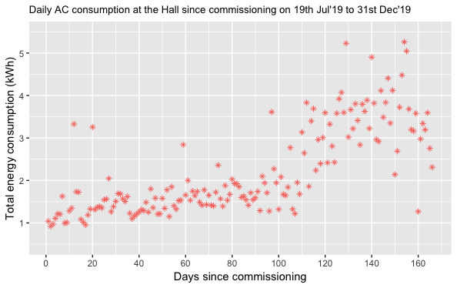

Fig. 9: Daily AC consumption (sum of 24 hours of mean AC consumption values) values at the hall and microgrid. A gap in data can be observed in micro-grid data owing to missing days of data files. Furthermore, while an increasing trend in consumption is noted in hall, the total consumption at the micro-grid is pretty constant implying not much, if any, increase in usage.

1. Daily average yield, capture loss and system loss at Hall and micro-grid – The final yield for each system is calculated as the net AC consumption per day. The capture losses are calculated by taking the difference between potential and actual PV power, and system losses are calculated as the difference between the actual PV power output and final yield. Accordingly, for each system, the AC consumption, potential PV power and actual PV power values are obtained. Only complete days of data collection i.e. days for which values for all variables is available for all 24 hours are used for the evaluation, with one exception at Micro-grid where data from 4th to 18th Sep is also included in analysis. This is done since a period where system is down implies high capture losses, and this should be included in subsequent system efficiency calculations. The daily values obtained per month are averaged for the below plots.

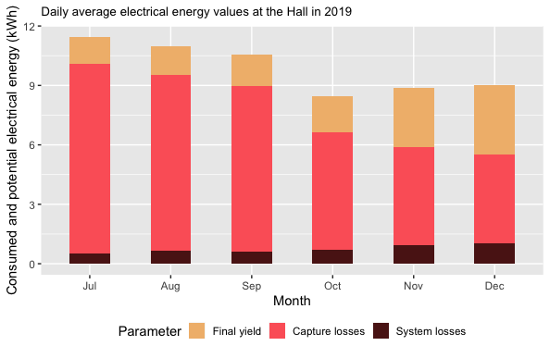

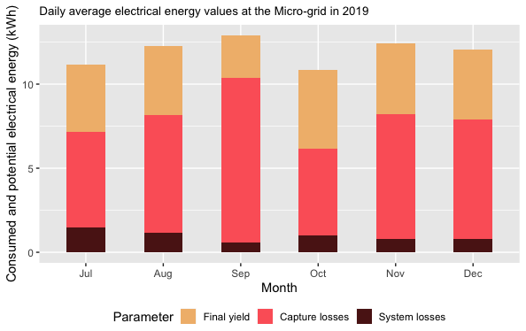

Fig. 10: Daily average yield, capture losses and system losses at hall and micro-grid from Jul to Dec 2019.

1. Energy use over and under prediction – Over and under prediction of energy consumption is calculated as the difference between the predicted consumption values and user load values. The over/under prediction is calculated for each hour where the energy consumption value is available for all sockets and CPE. For microgrid, the nursery 1A S1 is ignored and data from 4th to 18th Sep is removed.

Fig. 11: Over and under predictions of energy consumption at the hall from Jul to Dec 2019. The error in prediction is calculated as the difference between predicted and actual user load rounded up to the nearest 100. The first plot shows the distribution of error in prediction and the occurrence of various errors. The red line shows the median, the blue dotted lines show the first and third quantile, and the green dotted lines show the minimum and maximum values. For 50% occurrences, the error is 0Wh implying a close map between actual and predicted consumption. The second plot shows the scatter plot of error values over time of day for each month of study.

Fig. 12: Over and under predictions of energy consumption at the nurseries and playground from Jul to Dec 2019. The error in prediction is calculated as the difference between predicted and actual user load rounded up to the nearest 100. The first 2 plots shows the distribution of error in prediction and the occurrence of various errors for nurseries and playground. The red line shows the median, the blue dotted lines show the first and third quantile, and the green dotted lines show the minimum and maximum values. The next 2 plots show the scatter plot of error values over time of day for each month of study.

Figure 13a: Predicted and measured production factor, performance ratio, production efficiency and overall system efficiency at the hall since commissioning. Estimated and actual AC consumption is shown on the secondary axis.

Figure 13b: Predicted and measured production factor, performance ratio, production efficiency and overall system efficiency at the micro-grid since commissioning. Estimated and actual AC consumption is shown on the secondary axis.

The production factor is the ratio of actual PV yield to the potential PV yield. Performance ratio is the ratio of the final yield to the potential PV yield. Production efficiency represents the system losses and is given by PR/PF or AC load/PV power output. Overall system efficiency is the ratio of consumed energy to potential PV yield.

The below plots show typical day plots using predicted system data for hall and micro-grid

Predicted typical day plots for Microgrid are below

